DCN ASSIGNMENT – 4

Submitted By – Rishi Raj Chaurasia

Course – MCA 2nd SEM

Roll no. – 31

**Objective:**

Creating Social Graph of a person using GPS and Bluetooth data of 1 week.

**Theory:**

A social graph is a diagram that illustrates interconnections among people, groups and organizations in a social network. The term is also used to describe an individual's social network.

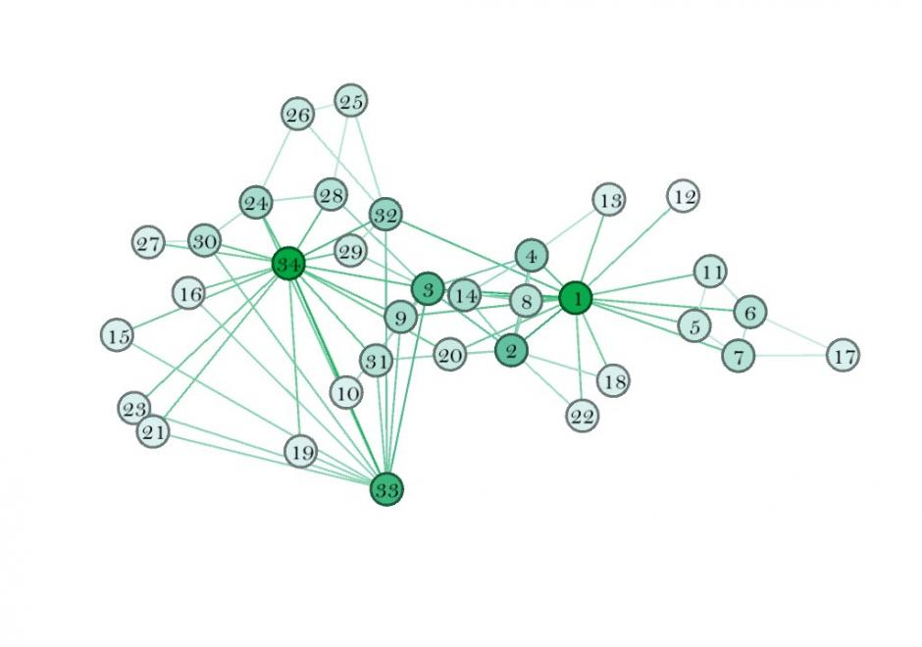

When portrayed as a map, a social graph appears as a set of network nodes that are connected by lines. Each node, which may also be referred to as an actor, is actually a data record. The connecting lines used to map relationships between data records are referred to as edges, ties or interdependencies.

When a social graph has a small number of nodes, it can easily be mapped on a whiteboard or piece of paper, using color-coded solid and dotted lines to indicate relationships. When the social graph has a large number of nodes, however, crisscrossed ties can quickly become tangled, making it difficult for anyone to get meaningful information out of the diagram. Graph database software makes it easier to analyze a large, complex social graph database through queries.

**Proposed Implementation:**

1. When a person installs the app, it detects the location of the device through GPS and devices available nearby using Bluetooth *(already implemented in the previous versions of the app).*
2. This process of collecting information is repeated every 10 mins and information gathered is stored locally in a database.
3. Also, while gathering the user information a data exchange through Bluetooth also takes place between the user and the nearby device having the same app installed.
4. Following data is exchanged with the nearby device:

* Media access control or MAC address *(of the discovered device).*
* Distance between the devices *(calculated using Bluetooth signal strength).*
* Device ID *(A static random ID computed from the personal information and the phone number of the users).*
* GPS latitude and longitude.
* Time at which the contact device was seen.
* Bluetooth Model name and number.

1. Using this information the social graph of the user can be constructed as shown in the above figure.
2. The figure will represent a directed acyclic graph which can be later displayed on a map using respective APIs.

**Note:** Currently I am unable to display the social graph due to unavailability of requisite data because due to the on-going lockdown situation, the location is concentrated to a single point and also no devices to detect nearby.

**Use of Social Graph in contact tracing for COVID-19:**

1. Suppose ‘**Person1’** and ‘**Person2’** meet each other for first time and have a 10 min conversation and have the app installed in their respective devices.
2. If both with the app are within range for several minutes, their phones trade codes via Bluetooth and create an encrypted record on their phones.
3. Both continues their day unaware that they had been near to a potentially contagious person.
4. A few days later, ‘**person2’** is positively diagnosed for COVID-19 and enters the test result in an app.
5. With **Person2’s** consent, his phone uploads the last 14 days of keys for his broadcast beacons to the cloud.
6. **Person1’s** phone periodically downloads the broadcast beacon keys of everyone who has tested positive for COVID-19 in his region. A match is found with the **Person2’s** anonymous identifier beacons.
7. ‘**Person1’** sees a notification on his phone alerting him of been exposed to an infected person.
8. **Person1’s** phone receives a notification with information about what to do next.